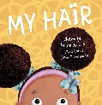
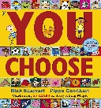
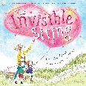
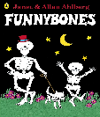
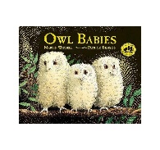
Understanding the World
Children will explore::
- Their own families and family traditions.
- Similarities and differences between families.
- Parts of the body.
- The nursery environment and where things belong. U
Children will learn about themselves, their families and the people who care for them. They will construct family homes and learn about different features such as doors, windows etc. They will make pebble people and create pebble family pictures.
- Children will learn about the natural environment through Forest School (Muddy Monday) and Autumn walks. They will learn about changes to the environment and look for the signs of Autumn.
- As a nursery we will enjoy talking about different celebrations and festivals.
- We will talk about the changes we had since we were babies and learn about parts of the body.

Literacy
- Begin to recognise their name.
- Enjoy sharing stories and nursery rhymes.
- Develop early mark-making and drawing skills.
Children will create self-portraits, helping them to represent themselves through drawing and talk about their features. Children will also use string to make and trace patterns, exploring different types of lines including zig-zags, spirals, straight lines and wavy lines.
We will read and retell a range of traditional tales, including Goldilocks and the Three Bears and The Three Little Pigs, helping children to develop their listening skills.

Children will learn to read their name on their peg and recognise letters in their name
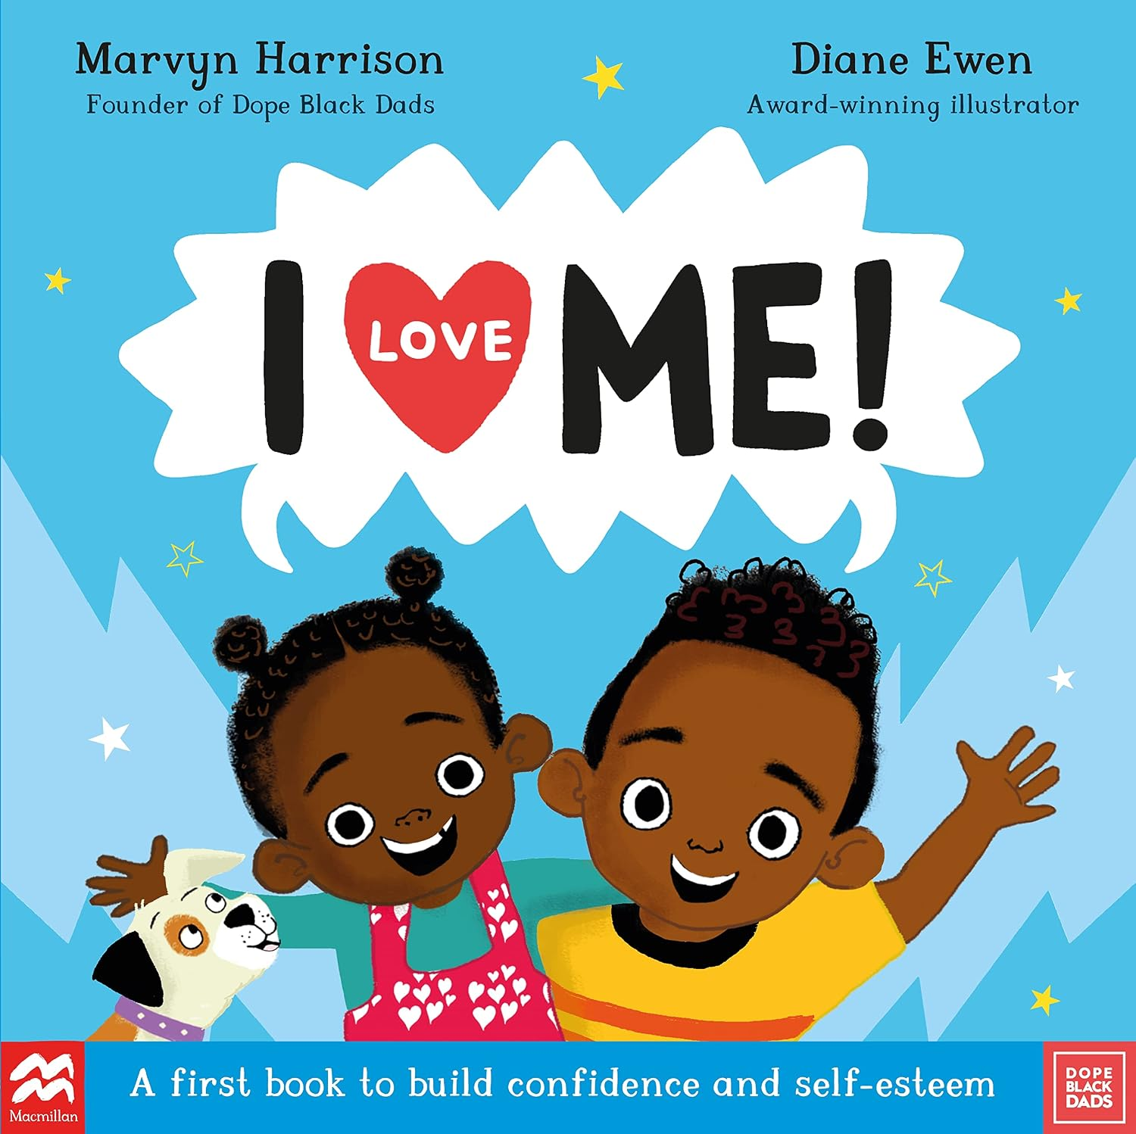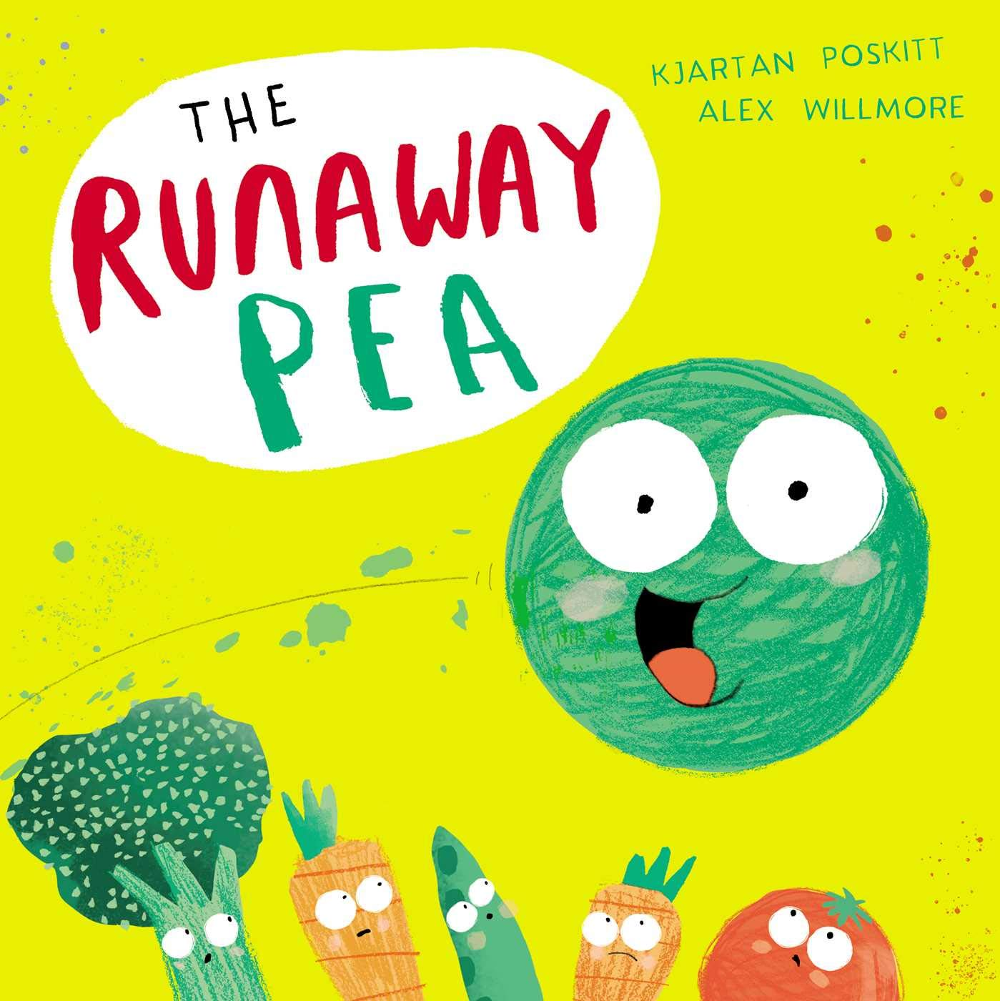

All about me
Communication and Language
- We will encourage children to talk about themselves and their families, developing confidence speaking to adults and friends.
- Listen carefully during stories, songs and carpet sessions.
- Build vocabulary linked to feelings, family and daily routines.
Children will take part in circle games, Bucket Time and daily discussions to encourage attention, listening and turn-taking. Children will be supported to talk about themselves, their families, their likes and dislikes, and their experiences.
Expressive Arts and Design
Children will have opportunities to:
- Explore colours and colour mixing.
- Create artwork from a variety of materials.
- Sing nursery rhymes and join in with music/movement.
- Express themselves through role play.
Children will explore a range of creative materials and techniques. They will make handprint artwork and use playdough to create faces – learning about facial features. Children will also design simple 'All About Me' collages using a variety of media, textures and materials.. They can create muddy pig prints, chicken tracks, or horse hoof marks, encouraging creativity, language development (“big”, “small”, “bumpy”), and early pattern ideas through movement and dance
Maths
Children will explore early mathematical concepts through practical play and daily routines:
- Children build on learning the days of the week / months of the year through singing songs. We will introduce our seasons song.
- Count through songs and rhymes.
- Recognising numbers 0, 1, 2 and 3.
- Exploring shapes, patterns and comparisons.
- Using mathematical language such as big, small, more and fewer.
Children will learn recite numbers beyond 5 and begin to show finger numbers up to 5. Children will also develop counting skills by counting their friends during circle time activities, complete simple jigsaws and matching activities. We will explore shape through construction activities and selecting shapes for different purposes.
Physical Development
Children will continue to develop:
- Gross motor skills through PE and outdoor play.
- Fine motor skills through cutting, drawing and creative activities.
- Independence with self-care routines.
- Awareness of healthy lifestyles and healthy eating.
Children will prepare healthy snacks, create fun fruit and vegetable faces, learn about foods that help keep their bodies healthy, and develop independence and confidence during snack times.

Personal, Social and Emotional Development
We will focus on helping children:
- Become confident and independent in nursery routines.
- Build positive relationships with adults and friends.
- Learn to share, take turns and work together.
- Recognise and talk about feelings.
- Develop a positive sense of self and celebrate what makes them special.
Children will make positive affirmation handprints, talk about their likes, dislikes and feelings, and take part in circle time discussions that celebrate what makes each of us different. We will create a special 'All About Me' chart to celebrate what makes each of them unique - sharing their favourite colour, eye colour, hair colour etc

Acorns Class 1 Curriculum Newsletter

