W/C 29.06.2020: Learning Project - FOOD
Class 4
Weekly Writing Tasks | Weekly Spelling Tasks
Monday- Visit the Literacy Shed for this wonderful resource on A Cloudy Lesson | Monday- Can your child list an adjective and food/drink item for every letter of the alphabet? E.g. crunchy carrot, creamy coffee.
Tuesday-. Encourage your child to write a review about a meal they’ve eaten. They can describe what they had to eat, what they enjoyed most about the meal and why? Are there any improvements that should be made to improve it? | Tuesday- Write an ideal shopping list that ensures their family will eat a balanced diet. List the items into alphabetical order using the first 2 or 3 letters of each word.
Wednesday- Choose a particular food and write an acrostic poem using the food name as a guide for the poem (an acrostic poem is a poem where certain letters in each line spell out a word or phrase). Think about where it comes from? What does it look like? What does it taste like? What is it eaten with? etc. | Wednesday- Choose 5 common exception words and practise spelling them using bubble letters.
Thursday- A new restaurant is opening in Shrewsbury. Ask your child to create an advert for the restaurant. Consider what food the restaurant specialises in, opening times, prices and location. Are there any chef specials? What makes this restaurant better than other restaurants? | Thursday- Ask your child to practise their spellings from yesterday by cutting letters out of a magazine or newspaper to make each word.
Friday- Can your child design packaging for a new, healthy cereal? Ask them to look at cereal boxes in the cupboard and create a criteria first. What do companies include e.g. a catchy slogan ‘They’re greeeaattt!’, a cartoon mascot, etc. | Friday- Your child can find out the meanings of these words: poultry, aroma, appetizer, cuisine & tasteless. Use the words in a sentence.
Weekly Reading Tasks | Weekly Maths Tasks- Place Value
Please continue to use Rising Stars to access comprehension activities. Please read the books and complete the questions | Please continue to complete the daily White Rose Maths activities.  - Please access the daily lessons available on The White Rose website. The videos can be found by following the link and the worksheets are attached on the home learning on the school website:  - Year 3 please complete Summer term- week 9 (w/c 22.6.20)- Right angles in shapes  - Year 4 please complete Summer term- week 9 (w/c 22.6.20)- Pounds and pence
Monday- Encourage your child to read for enjoyment- can they locate a book about food e.g. Charlie and the Chocolate Factory? | Monday- Give your child a three or four digit number and ask them to draw a poster showing all the ways that the given number could be represented.
Tuesday- Ask your child to look at recipe books. Can they identify the features of a recipe? E.g. Subheadings, adverbs (slowly, carefully) and imperative verbs (slice). | Tuesday- Write the digits 0 - 9 on separate pieces of paper and place them spread out on the ground. Give your child 3 or 4 bean bags or teddies (or something soft) and ask them to throw each one on the digits on the floor. With these digits, how many different numbers can they make? Can they find them all?
Wednesday- Watch this BBC Bitesize clip on ‘A Healthy Diet’. Ask your child to summarise what they’ve learned by writing a small paragraph. | Wednesday- Write a selection of 3 or 4 digit numbers and split them into pile A & pile B. Get your child to select a number from each pile and compare them using the symbols < (less than), > (greater than) and = (equal to) and justify how they know. E.g. 3421 < 3451 because the hundreds and thousands are the same but 4 tens is smaller than 5 tens.
Thursday- Your child could call or Facetime a relative (with supervision). Your child could then interview them about their favourite book or author. | Thursday- Play ‘Place Value War’ using a pack of cards with your child (you can make digit cards on paper if you do not have real cards). Deal the cards into 2 (for playing with tens), 3 (for playing with hundreds) or 4 (for playing with thousands) piles per player. Each player turns the top card on each pile and makes a number. The player with the highest number wins the cards from everyone and puts them in a separate pile. Repeat.
Friday- Ask your child to read this extract from 100 Adventures to have Before you Grow Up. Talk to your child about adventures they’d like to have too. | Friday (theme)- Ask your child to collect a range of food/drink items in your home. Get them to read how many grams or millilitres there are by looking at the packages and write them down. Get them to order the numbers they have recorded from smallest to largest.

Learning Project - to be done throughout the week
The project this week aims to provide opportunities for your child to learn more food. Learning may focus on where different foods originate from, what makes a healthy meal, opportunities to cook etc.

- Finding Facts about Food- What is a balanced diet? Encourage your child to find out about the different food groups. Make a poster or a PowerPoint/Google Slides presentation about the groups and what a healthy diet is. Here are some videos to support the learning: carbohydrates, protein, dairy and alternatives,
fruits and vegetables and fats. As a challenge, your child could investigate where their food comes from. Which foods come from the UK? What would we eat if we could only source food from the UK?

- The Great Giuseppe Arcimboldo- Look at the artwork of Giuseppe Arcimboldo. Maybe recreate some of his paintings with real fruit and vegetables. If not, recreate one of his pieces using pencils, crayons or another material of choice. Alternatively, use fruit and vegetables to create some decorative prints e.g. potatoes, cauliflower or carrots. These could be repeated pattern prints.

- Energy and Exercise- Food provides us with energy and we need energy to exercise; exercise keeps us fit. Ask your child to choose a dance from Supermoves. Following this, they can choreograph their own dance. They may want to plan the dance first by sketching ideas for their new routine. Ask them to perform it to the family.

- Planning and Preparation- As a family, design a healthy meal plan for the week. Discuss favourite foods and why they enjoy them? Talk about healthy and unhealthy foods and explain the importance of eating a balanced diet. Why not write the weekly shopping list together and ask your child to categorise each food item? Perhaps you could prepare some meals together? Task your child with measuring and weighing ingredients.

- Lunch Around the World- Look at lunch around the world and investigate how people eat in other parts of the world. Can your child locate the countries mentioned on a world map? Ask your child to create a fact file or mini book about their findings. Which country is most similar to the UK? Which is most different? Why? Why not find out about people who choose alternative diets such a vegetarian, vegan or somebody who eats Kosher food?

Additional learning resources parents may wish to engage with
- BBC Bitesize - Lots of videos and learning opportunities for all subjects.
- Classroom Secrets Learning Packs - Reading, writing and maths activities for different ages.
- Twinkl - Click on the link and sign up using your email address and creating a password. Use the offer code UKTWINKLHELPS.
- White Rose Maths online maths lessons. Watch a lesson video and complete the worksheet (can be downloaded and completed digitally).
- Times Table Rockstars and Numbots. Your child can access both of these programmes with their school logins. On Times Table Rockstars, children should aim to play Soundcheck for 20 minutes daily.
- IXL online. Click here for Year 3 or here for Year 4. There are interactive games to play and guides for parents.
- Mastery Mathematics Learning Packs. Take a look at the mastery mathematics home learning packs with a range of different activities and lessons.
- Y3 Talk for Writing Home-school Booklets and Y4 are an excellent resource to support your child’s speaking and listening, reading and writing skills.
The Learning Projects are based on the National Curriculum expectations for the key stage which your child is in. It may be that your child finds the tasks set within the Learning Project for their year group too simple. If this is the case, then we suggest that your child accesses the Learning Projects which are set for the key stage above. Equally, if the projects are too challenging, then we advise that your child accesses the projects for the key stage below.
If your child requires more of a challenge, or you believe that there are some gaps in their learning then Century Tech is a fantastic resource that is currently free for home learning. The app is designed to address gaps and misconceptions, provide challenge and enables children to retain new knowledge. It uses artificial intelligence to tailor the learning to your child’s needs. Sign up here.
#TheLearningProjects
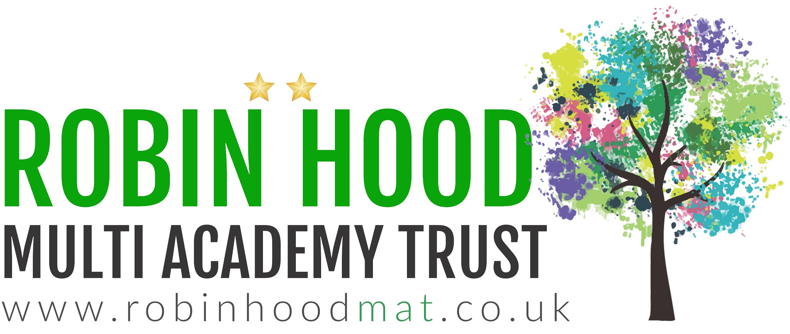
www.robinhoodMAT.co.uk

