Week 5- Learning Project - Sport
Class 4
Weekly Reading Tasks | Weekly Spelling Tasks
Monday- Your child could write their very own celebration song. | Monday- Task your child with choosing 5 sporting activities that they’re unsure of how to spell and encourage them to learn to spell them. Can they apply these words into sentences?
Tuesday- Ask your child to choose a sports person they admire. Get them to write a list of questions they would like to ask them. They could answer in role as their hero. Ensure your child uses a range of question words. | Tuesday- Practise spelling these words: myth, gym, Egypt, pyramid, mystery. Can your child identify the spelling rule? (The ‘ɪ’ sound spelt ‘y’ elsewhere than at the end of words).
Wednesday- Your child could devise their very own sport, including rules, equipment needed and a scoring system. Why not test the sport out? | Wednesday- Alphabetical order: List each letter of the alphabet and ask your child to think of a sport related word that corresponds with each letter.
Thursday- Encourage your child to continue this story starter (right of site) and write their own Underwater Olympics story using this picture as a stimulus. | Thursday- Rainbow words. Choose 5 common exception words and choose different colours to write each letter and create rainbow words.
Friday- Ask your child to choose a sport, which is popular in another country, and write their own set of instructions for how to play that particular sport. | Friday- Proofread writing tasks from this week. Your child can use a dictionary to check any spellings that they’re unsure of using the first 2/3 letters of the word.
Weekly Writing Tasks | Weekly Maths Tasks- Position and Direction
If you haven’t already, please sign up to Rising Stars following the link. Once you have registered please let me know and I can assign your child a text. Please read the books and complete the questions alongside them. | Please continue to complete the daily White Rose Maths activities.  - Please access the daily lessons available on The White Rose website:  - Year 3 please complete Summer term- week 2 starting with lesson 1- adding fractions  - Year 4 please complete Summer term week 2- starting with lesson 1- round decimals
Monday- Encourage your child to read for enjoyment- perhaps in the garden for a change. | Monday- Get your child to watch this video explaining coordinates and how to plot them using the x-axis first, then the y-axis.
Tuesday- Visit Worldbookonline eBooks using Username: wbsupport and Password: distancelearn. Choice the ‘kids’ icon and search for the title Play Sports! Ask your child to read the eBook. Encourage them to complete the activities at the back of the book. | Tuesday- Set up a treasure hunt in your home/garden. Ensure your child knows where the origin (0,0) is and ask them to take 4 steps to the right and 7 steps forward to find the ‘treasure’ at (4,7). Change your instructions so you are just saying the coordinate and children have to move to the position independently.
Wednesday- Research and read online with your child about The Olympics. Which sport/s would they like to try? Why? Write 10 facts about The Olympics. | Wednesday- Ask your child to play Alien Attack using the first quadrant. Can they describe the positions of the alien spaceships? Then encourage them to play ‘Hit the Coordinate’ to practise plotting coordinates on a grid.
Thursday- Listen to these BBC children’s sport podcasts. Or your child can look through newspapers/ magazines and list all of the sporting vocabulary they find. | Thursday (theme)- Set up a Times Table relay race. Can your child run lengths of a space and count in their times tables forwards and backwards?
Friday- Complete the weekly reading activity on the BBC Bitesize Daily lessons  - Year 3  - Year 4 | Friday (theme) - Can your child identify the average temperatures in these Olympic-hosting countries and then order them? France, Germany, Canada, Norway and Russia.

Learning Project - to be done throughout the week
The project this week aims to provide opportunities for your child to learn more about sports and games. Learning may focus on the history of sport, sporting-heroes, physical challenges and performance.

- Our Sport Heroes- How many famous sports people can your child name? Ask them to choose a sports person and research online about them. Can they find out how and when they started their career, or any other interesting facts about them? Encourage your child to create a timeline that details all of the achievements of their sporting hero.

- Tissue Paper Sports Logo - Ask your child to use scrunched up tissue and paint to recreate the logo for their favourite sport team or design and create their own sport logo, perhaps for their school team. Your child could sketch this with pencils as an alternative.

- Super Movers! - Encourage your child to take part in this football themed Super Movers! There are two levels - Super Movers are a great way to keep active and have fun! Try Go Noodle and dance along to one of their routines - there’s plenty to choose from and the whole family can join in!

- Sharing Sport Interests - Encourage your child to ask different family members about their favourite sports and any sports they took part in growing up - were they a part of any clubs? Did they take part in any competitions? Did they win any trophies? They might find out something new about their family members! Following this, can your child use the information to write a newspaper report recounting one the memorable events? They could include quotes from the interview.

- Powerful Paralympians - You could explore diversity in sport with your child. Ask your child to find out about the Paralympic games and famous paralympians such as Ellie Simmonds. How have these people overcome challenges to represent their country in their chosen sport? They could write a letter/email to a chosen athlete and ask them questions about their sporting journey. Or they could draw a detailed sketch of the athlete during a winning moment.

- Foundation subjects: please continue with the activities set from week 3.
Geography: The topic for this term is Rivers. Please research the river that runs through Shrewsbury. What can you find out about it? How long it is? Where it starts? Where it ends? Can you find it on a map?
French: On Languagenut please begin to look at the ‘Where people work’ topic. This can be found on Languagenut- Topics- Me and my family- About me- Where people work.
Art: This terms Art topic is African Patterns- please research these.
Are there any artists famous for this style of art? Do different areas of Africa have different styles? What is used to create the patterns? Are there any particular colours used- why?
STEM Learning Opportunities #sciencefromhome
Body Facts or Body Fiction
- Have a look at the body facts or body fiction worksheet here.
- Use a ruler or tape measure to find out if your foot is as long as your forearm or your height is the same as your arm span. The complete resource can be downloaded here.
Additional learning resources parents may wish to engage with
- BBC Bitesize - Lots of videos and learning opportunities for all subjects.
- Classroom Secrets Learning Packs - Reading, writing and maths activities for different ages.
- Twinkl - Click on the link and sign up using your email address and creating a password. Use the offer code UKTWINKLHELPS.
- White Rose Maths online maths lessons. Watch a lesson video and complete the worksheet (can be downloaded and completed digitally).
- Times Table Rockstars and Numbots. Your child can access both of these programmes with their school logins. On Times Table Rockstars, children should aim to play Soundcheck for 20 minutes daily.
- IXL online. Click here for Year 3 or here for Year 4. There are interactive games to play and guides for parents.
- Mastery Mathematics Learning Packs. Take a look at the mastery mathematics home learning packs with a range of different activities and lessons.
- Y3 Talk for Writing Home-school Booklets and Y4 are an excellent resource to support your child’s speaking and listening, reading and writing skills.
#TheLearningProjects
in collaboration with
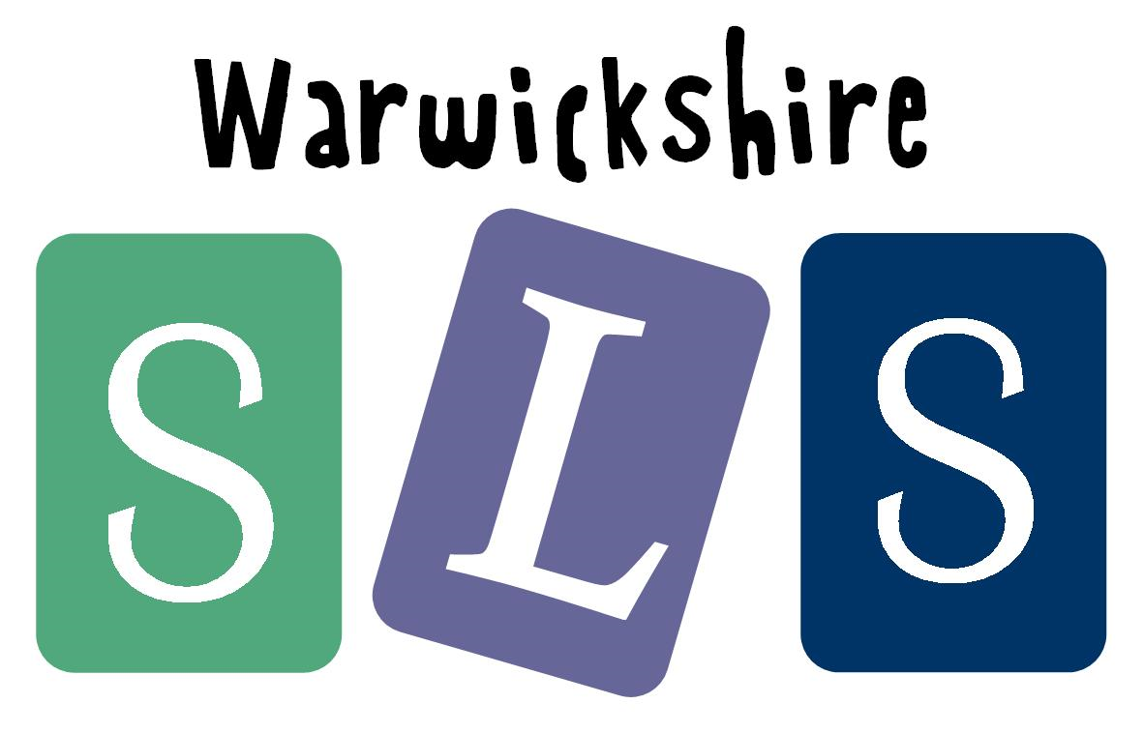
www.robinhoodMAT.co.uk

