**Suggestions for EY parents to support with home learning environments**

**Dandelion Activities**

At the moment the lawns and grass verges are a splash of yellow as the dandelions are out in full bloom. I never knew there were so many activities you could do with dandelions. Below is just a selection of activities with their websites if you want to explore more.

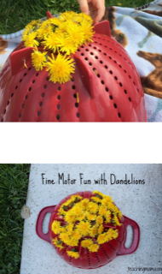 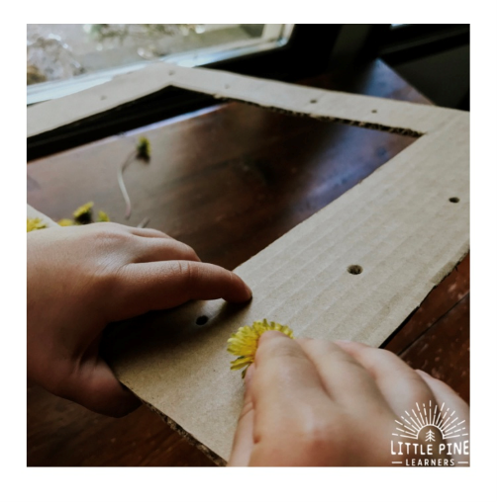

What a simple idea.

Excellent for fine motor control and hand /eye co-ordination. Take it further by pushing the dandelions into a cardboard frame

[www.teachingmama.org](http://www.teachingmama.org) [www.littlepinelearners.com](http://www.littlepinelearners.com)

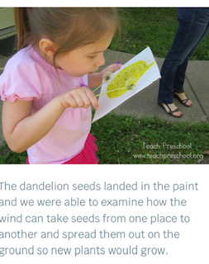

Mix paint with glue (just paint will also work but not as well), paint on to thin card. Take it outside and blow the dandelion seeds onto it.

The idea and photograph are from

[www.littlepinelearners.com](http://www.littlepinelearners.com)

**Dandelion Activities cont.**

The Muddy faces website has a wealth of activities to do, all involve being outside (your garden is fine). Below is a recipe for Dandelion Jam. The cooking part of this will be adult only as it involves boiling water but the children can collect and prepare the dandelion petals. I have never heard of dandelion jam but I am assured it tastes delicious

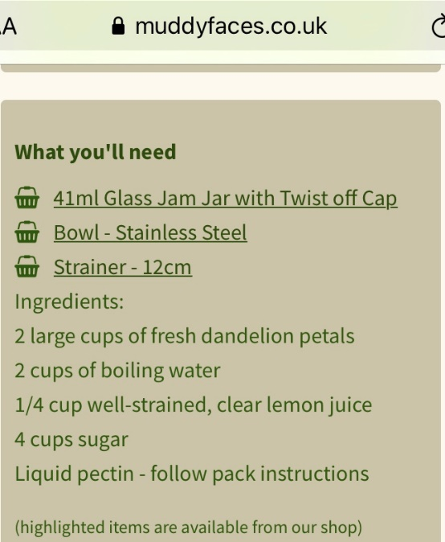 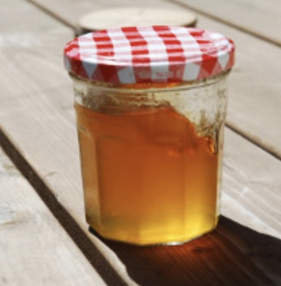

Step1: Separate the petals from the dandelion flowers, try to minimize the amount of green you get

Step 2: Cover with boiling water and allow to cool

Step 3: Strain the petals using a muslin cloth or coffee filter or a clean tea towel

Step 4: On a low heat combine the dandelion liquid, sugar and lemon juice. Stir until the sugar has dissolved.

Step 5: Bring to the boil, then add the liquid pectin, stirring continuously bring it back to a full boil for 1 minute

Step 6: Remove from the heat and fill the warm jars using a funnel. Put on the lids and allow to cool.

[www.muddyfaces.co.uk](http://www.muddyfaces.co.uk)

**Mark Making is fun**

Outdoor mark-making can be messier and done on a larger scale

• Use brushes or squeezy bottles to ‘paint’ with water on a patio, fence or wall.

• Draw with sticks in damp sand or mud.

• Zoom bikes and toy cars through a puddle to make track marks.

• Sketch with chunky chalks on tarmac.

Messy mark-making inside

• Mix table salt with glitter in the lid of a biscuit tin, then make letter shapes and patterns in the ‘sparkledust’.

• Draw with fingers in a tray of flour, shaving foam or ‘gloop’ (cornflour and water).

• Trickle different colours of icing onto fairy cakes.

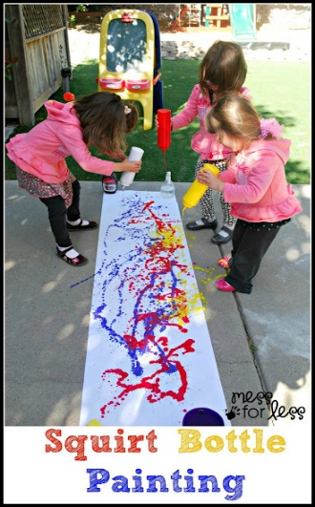

• Let children decorate themselves, each other or you(!)

with face paints or bath crayons.

Or Mess-free mark-making

• Try magnetic drawing boards and water drawing mats.

• If you have a tablet, there are lots of free children’s

art apps available such as Paint Sparkles or Pixie Dust.

<https://www.pacey.org.uk/Pacey/media/Website-files/school%20ready/Make-a-mark,-make-a-start.pdf>

Photo from [www.messforless.net](http://www.messforless.net)

**Stories**

Stickman by Julia Donaldson

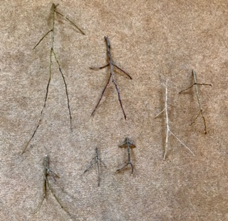

Most of you will be familiar with Stickman by Julia Donaldson. Here is a fun activity whilst on your daily walk or in your back garden.

Dancing stickmen

How many can you find?

The Tiger who came to tea by Judith Kerr We’re going on a bear hunt by Michael Rosen

On YouTube there is a video of Billy Bragg singing a version of these stories

**Tiny Happy People**

**Your words build their world**

“Tiny Happy People is here to help you develop your child’s communication skills. Explore our simple actiivities and play ideas …”

There are lots of ideas on this website for parents to do with their young children. Below are just a few examples, they all have accompanying videos

www.bbc.co.uk/tiny-happy-people/

**0-3months**

**What's catching baby's eye?  
A great way of teaching your baby words from their very early days is to name the objects that catch their eye.**Take notice of the things that grab their attention and tell them what they are. Repeat the words a few times to reinforce what you're saying.  
<https://www.bbc.co.uk/tiny-happy-people/name-the-object/z4ngy9q>

**9-12months+  
Playing games with a box  
Who knew you could have so much fun with a cardboard box?!**These simple games are a great way of playing together and will help develop your baby's social and interacting skills  
<https://www.bbc.co.uk/tiny-happy-people/playing-games-with-a-box/z4ffscw>

**12-18months+  
Musical activities: How to make a jam jar xylophone for your toddler  
Fancy having some noisy fun with your baby? All you need is some clean, empty jam jars, a spoon and a tap!**Watch the film to find out how to make a jam jar xylophone.  
As you play, talk to your baby about what they're doing - use words like 'loud', 'quiet' and 'noisy'. If you're using food colouring,name the different colours too.  
***When playing, make sure your baby is under close supervision at all times and be careful when hitting glass jars with spoons. In the case of any breakages, make sure that your child is kept well away from the area until all glass is cleared away***<https://www.bbc.co.uk/tiny-happy-people/jam-jar-xylophone/zrgkvk7>

**3-4 years  
Getting ready for the day  
Chatting with your child whilst they get ready for the day encourages them to form longer and more descriptive sentences.**You could ask them to talk through the order of which clothes they are putting on, asking questions like 'what are you putting on first?' or 'what's next?[https://www.bbc.co.uk/tiny-happy-people/getting-ready-for-the-day/zdxvy9q](https://www.bbc.co.uk/tiny-happy-people/getting-ready-for-the-day/zdxvy9q%20%20%20%20%20)