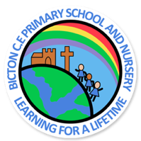

CLASS 3 – SUMMER 2019

NEWSLETTER



**English**

This term our English will be linked to our geography topic and we will be reading a range of stories such as *‘Possum Magic’* and *‘The koala who could’.* Non-fiction writing will include information texts and holiday brochures. The children will also be writing poetry, postcards and stories.

Alongside this they will be continuing with the ‘Read Write Inc.’ programme to develop their reading, writing, spelling and comprehension skills.

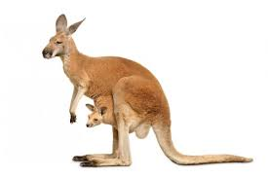

**Maths**

The topics we will cover in maths this term will be measurement – length, height, time, capacity and temperature; statistics, position and direction and problem solving using efficient methods. The children will use a range of skills to solve a range of reasoning and problem style questions.

**Topics**

**Geography** – This term, our topic is Australia. We will be continuing with our map work by locating continents, oceans and cities/states within Australia. We will focus on areas such as: physical / human features, animals, culture and a comparison with the U.K.

**Science** – we will be exploring ‘Living things and their habitats’ and a carrying out a range of scientific investigation work linked to this.

**RE** – we will be focussing on the key questions: ‘God: What do Christians believe God is like?’ and ‘Islam: What are the five pillars of Islam?’

**P.E.**

Our P.E. sessions for this term are on Tuesday and Thursday. The children will be participating in a range of games and athletics activities. Please remember to bring your PE kit in at the start of the week and take home each Friday.

**Spellings and Homework**

Spellings will be given out every **Friday** and the children will be tested every Friday morning. Homework will continue to be linked to the times tables and the children will tested on these on a weekly basis (on a Monday). They will also be set half termly projects based on work they are doing in class.

We are looking forward to another fun and challenging term with Class 3 and hope that the children will enjoy all of the new topics. If you have any further questions, please do not hesitate to ask.

Mrs Thomas and Miss Moran