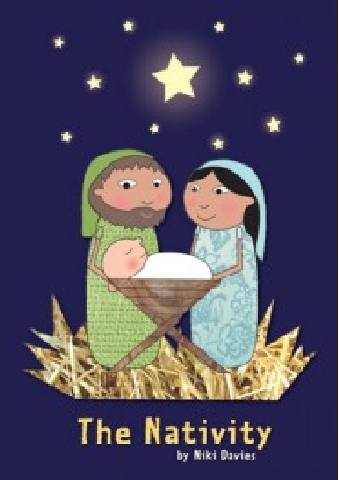
The Nativity.

The children and staff are very excited that it is that time of year again for the Christmas production!
Please find details below of the part your child will be playing in the production and details of any items of clothing they might need to bring in from home. If you have any difficulty getting hold of any of this, please don’t hesitate to let us know. Please bring your child’s costume from home in a named carrier bag no later than Wednesday 7th December.

The children have also been given their lines to learn, please support them with this, 10 minutes a day is better than an hour at a time! If your child has got more than one line to say, it is important that they know when to say their bit eg. they listen out for the previous line!

If you have any questions at all, please don’t hesitate to come and ask us!
Kind regards

Miss Edwards and Mrs Bowes.

Donkeys: Harry P and Megan - plain clothes to go under costume

Lambs: Devon, Sam, Daniel, Arley - black bottom and long sleeve black top

Camels: Archie, Dylan, Myles – black/brown top bottoms and top

Shepherds: Nathan, Harry S – plain dark clothes to wear under outfit

Angels: Matilda, Zoe, Sennen, Caitlin, Ophelia, Lana – white tights/leggings and top

Stars: Sophie, Maisie, Mishka, Bethan, Isabelle – black tights/leggings and top

Mary: Sammy - plain clothes to go under dress

Joseph: Bobby - plain clothes to go under outfit

If you would like to provide your child with a suitable full costume, we would be very grateful. Please let the teacher know if you are able to do this.

